AMERICAN INTERNATIONAL UNIVERSITY-BANGLADESH (AIUB)
Faculty of Science & Technology

Department of Chemistry

PROBLEMS: (Atomic structures, electronic configuration and quantum numbers)

Problem 1. Calculate the radius of third orbit of hydrogen atom (h = 6.625 × 10⁻²⁷ erg-sec; m = 9.9091 × 10⁻²⁸ g; e = 4.8 × 10⁻¹⁰ esu).

Problem 2. Calculate the wavelength of the first line in Balmer series of hydrogen spectrum (R = Rydberg’s constant = 109677 cm⁻¹).

Problem 3. Calculate the wavelength associated with an electron moving with a velocity of 1×10⁸ cm sec⁻¹. (Mass of electron = 9.1×10⁻²⁸ g.).

Problem 4. A particle having a wavelength 6.6×10⁻⁴ cm is moving with a velocity of 10⁶ cm sec⁻¹. Find the mass of the particle. (Planck’s constant, h =6.62×10⁻²⁷ erg-sec.)

Problem 5. Calculate the wavelength of an electron having kinetic energy equal to 4.55 × 10⁻²⁵ J. ( h =6.6×10⁻³⁴ kg m² sec⁻¹ and mass of electron = 9.1×10⁻³¹ kg ).

Problem 6. Calculate the uncertainty in position of an electron if the uncertainty in velocity is 5.7 × 10⁵ m sec⁻¹.

Problem 7. What is the wavelength associated with a particle of mass 0.1g moving with a speed of 1 × 10⁵ cm sec⁻¹. ( h =6.6×10⁻²⁷ erg sec).

Problem 8. The uncertainty in the position of a moving bullet of mass 0.01 kg is 1.0×10⁻⁵ m; calculate the uncertainty in its velocity. (Ans. 5 ×10⁻²⁸ msec⁻¹)

Problem 9. What is the mass of a photon of sodium light with a wavelength of 5890 Ǻ? (Hints: λ=h/mv; h =6.6×10⁻²⁷ erg sec, λ=5890×10⁻⁸cm, v= 3×10¹⁰cm/sec; Ans. 3.76 ×10⁻³³ g)

Problem 10. The uncertainty in the position and velocity of a particle are 10⁻¹⁰ m and 5.27 × 10⁻²⁴ m sec⁻¹ respectively. Calculate the mass of the particle. (Given Planck’s constant, h = 6.6×10⁻³⁴ kg m² sec⁻¹).

Problem 11. The velocity of a ball being bowled by Mohammad Rafiq is 25 m sec⁻¹. Calculate the wavelength of the matter-wave associated with the ball. (Weight of the ball = 158.5 g; h = 6.625 × 10⁻²⁷ erg sec).

Problem 12. (a) An atom of an element contains 13 electrons. Its nucleus has 14 neutrons. Find out its atomic number and approximate atomic weight. Indicate the arrangement of electrons and the electro-valency of the element. (b) An isotope of the above element has atomic weight 2 units higher. What will be the number of protons, neutrons and electrons in the isotope?

Problem 13. (a) How many electrons are there in hydrogen and chlorine atom (atomic number 17)? How they are arranged? What is the valency of hydrogen and chlorine in HCl? (b) The atomic number of Na and Cl are 11 and 17 respectively. Determine the number of electrons in Na⁺ and Cl⁻.

Problem 14. (a) Write the electronic configurations of elements with atomic numbers 19, 28 and 29. (b) Calculate the atomic number and name the element that corresponds to each of the following electronic configuration:
(i) 1s², 2s² 2p⁶, 3s² 3p⁶, 4s¹
(ii) 1s², 2s² 2p⁶, 3s² 3p⁶ 3d⁵, 4s¹
(iii) 1s², 2s² 2p⁶, 3s² 3p⁶ 3d¹⁰, 4s¹

Problem 15. (a) An electron is in 4f orbital. What possible values for the quantum numbers n, l, m and s can it have? (b) What designation is given to an orbital having (i) n=2, l=1 and (ii) n=4, l=0?

Problem 16. A neutral atom has 2K, 8L, 5M electrons. Find out the following from the data (a) atomic number, (b) total number of s electrons, (c) total number of p electrons, (d) number of protons in the nucleus, and (e) valency of elements.

Some Problems & Solutions
(Atomic structure, Uncertainty Principle & Quantum Numbers)

1. What is the wavelength of a 70 kg skier traveling down a mountain at 15m/s?
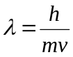
Ans: We know,
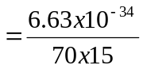

= 6.31 x 10 ⁻³⁷ m.

2. What is the energy required to remove an electron from hydrogen in its ground state?

Ans: Z=1 for hydrogen;

In this case, we are moving an electron from n=1 to n= infinity. And thus the energy required will be equal to
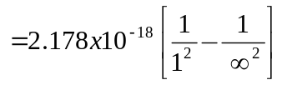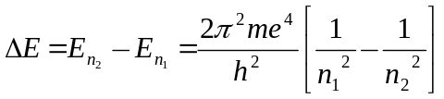, Here n₁=1, n₂= ∞

= 2.178 x 10 ⁻¹⁸ J
Since the value of the energy is positive, it indicates that the energy must be absorbed to remove the electron.
The energy we just calculated is also known as the ionization energy of hydrogen.

3. Calculate the wavelength associated with an electron moving with a velocity of
1x10⁶ m sec⁻¹. [Mass of an electron = 9.1x10⁻³¹ kg.]
Ans: We know,
E = mc²
= (9.1x10⁻³¹) x (1x10⁶)²
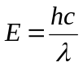 = 9.1x10⁻¹⁹ J

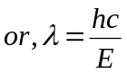
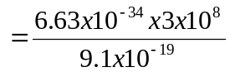Again,

2.185 x 10⁻⁷ m

4. The uncertainty in position and velocity of a particle are 10⁻¹⁰m and 5.27 × 10⁻²⁴
m sec⁻¹ respectively. Calculate the mass of the particle.

Ans. According to Heisenberg’s uncertainty principle,
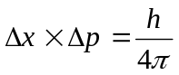 or, 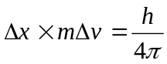 or, 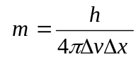
Here, Δv = 5.27 × 10⁻²⁴ m sec⁻¹, h = 6.6 × 10⁻³⁴ kg m² sec⁻¹ and 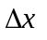= 10⁻¹⁰ m

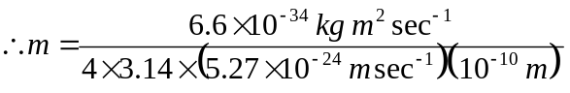

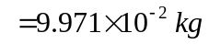
= 99.711 g Ans.

5. Which of the following sets of quantum numbers are not allowable and why?

i) n=2, l=2, m=0, s= +½
ii) n=3, l=1, m=0, s= -½
iii) n=1, l=1, m=+1, s= +½
iv) n=2, l=0, m=-1, s= 0
v) n=3, l=2, m=+2, s= -½

Ans: i) Not allowable as l can not have value equal to 2 when n=2,
ii) Allowable,
iii) Not allowable as l can not have value equal to 1 when n=1,
iv) Not allowable as ‘s’ can not have value equal to 0,
v) Allowable

Assignment

1. Calculate the wavelength of light emitted from the hydrogen atom when the electron undergoes a transition from level n= 3 to level n = 1. What is the name of the series produced by this transition? What will be the wave number for this transition? What will be the frequency?

Sol^{n}: Here given that n₁= 1 and n₂= 3
We know that 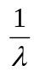 = 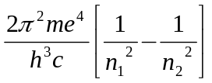

or, = 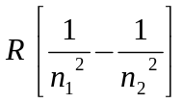where R is the Rydberg constant having value 109,676 cm⁻¹
Putting the values we get,

= 109676 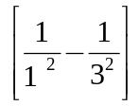 cm⁻¹
or, = 109676 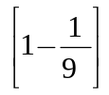 cm⁻¹
or, = 109676 x 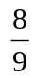 cm⁻¹
∴ λ = 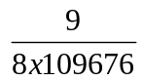 cm
= 1.025 x 10⁻⁵ cm or, 1.025 x 10⁻⁷ m Ans.

Since the electron is falling to n₁= 1 from upper level so it will produce Lyman series.

Wave number, = = 97489.77 cm⁻¹
Frequency, ν= 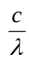 where c= velocity of light = 3x10⁸ ms⁻¹
So, ν = 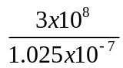 Hz
= 2.9268 x 10¹⁵ Hz

2. What is the difference in energy between the two levels of the sodium atom if emitted light has a wave length of 589 nm?

Sol^{n}: Given that, λ = 589 nm = 589 x 10⁻⁹ m
h = 6.62 x 10⁻³⁴ J sec.
c =3x10⁸ ms⁻¹
We know that, 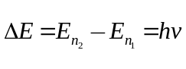
So 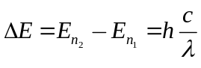
∴= 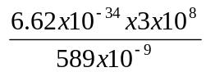 Joule
= 3.3718 x 10⁻¹⁹ Joule

3. The green line in the atomic spectrum of thallium has a wave length of 535nm. Calculate the energy of a photon of this line.
Sol^{n}: We know that, E= hυ = 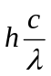
= 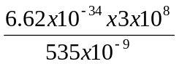 Joule = 3.712 x 10⁻¹⁹ Joule Ans.

4. An electron in a hydrogen atom in the level n= 5 undergoes a transition to level n=3. What is the frequency of the emitted radiation?

Sol^{n}: Here given that n₁= 3 and n₂= 5
We know that =
or, = where R is the Rydberg constant having value 109,676 cm⁻¹
Putting the values we get,
= 109676 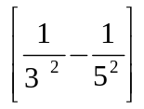 cm⁻¹
or, = 109676 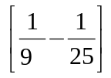 cm⁻¹
or, = 109676 x 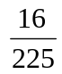 cm⁻¹
∴ λ = 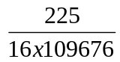 cm
= 1.282x 10⁻⁴ cm
= 1.282 x 10⁻⁶ m
Now the frequency, υ = where c= velocity of light = 3x10⁸ ms⁻¹
∴υ = 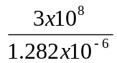 Hz
= 2.34 x 10¹⁴ Hz. Ans.

5. Calculate the longest wavelength of the electromagnetic radiation emitted by the hydrogen atom in undergoing a transition from the n = 6 level.

Solution: For being the longest wavelength of the electromagnetic radiation emitted by the hydrogen atom due to a transition from the n = 6 level, energy should be very small. So it can be said that transition from the n = 6 to n = 5 level will be lower energy transition. Where transition from the n = 6 to n = 1 energy will be higher.

So for longest wavelength, n₁= 5 and n₂ = 6
We know that =
or, = where R is the Rydberg constant having value 109,676 cm⁻¹
Putting the values we get,
= 109676 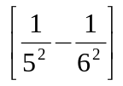 cm⁻¹
or, = 109676 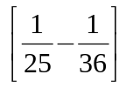 cm⁻¹
or, = 109676 x 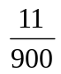 cm⁻¹
∴ λ = 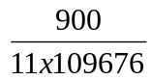 cm
= 7.459 x 10⁻⁴ cm
= 7.459x 10⁻⁶ m. Ans. 7.459x 10⁻⁶ m.

6. Calculate the shortest wavelength of the electromagnetic radiation emitted by the hydrogen atom in undergoing a transition from the n = 6 level.

Solution: For being the shortest wavelength of the electromagnetic radiation emitted by the hydrogen atom due to a transition from the n = 6 level, energy should be high. So it can be said that transition from the n = 6 to n = 1 level will be higher energy transition. Where transition from the n = 6 to n = 5 energy will be lower.

So for shortest wavelength, n₁= 1 and n₂ = 6
We know that =
or, = where R is the Rydberg constant having value 109,676 cm⁻¹
Putting the values we get,
= 109676 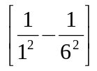 cm⁻¹
or, = 109676 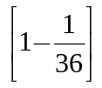 cm⁻¹
or, = 109676 x 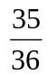 cm⁻¹
∴ λ = 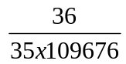 cm
= 9.378 x 10⁻⁶ cm
= 9.378 x 10⁻⁸ m. Ans. 9.378 x 10⁻⁸ m.

7. A line of the Lyman series of the hydrogen atom spectrum has the wavelength 9.50x10⁻⁸ m. It results from a transition from upper energy level. What is the principle quantum number of that upper level?

Solution: Since line is of the Lyman series so n₁= 1 and n₂ =? Here λ = 9.50 x 10⁻⁸ m = 9.50x10⁻⁶ cm.
[Since Rydberg constant is in cm⁻¹ unit so we are taking wavelength in cm unit]
We know that =

or, = where R is the Rydberg constant having value 109,676 cm⁻¹
Putting the values we get,
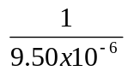 = 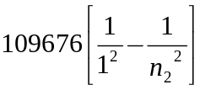
or, 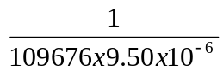 = 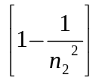
or, 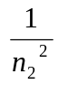 = 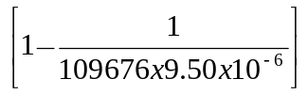
or, = 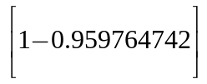
or, = 0.040235257
or, 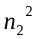= 24.8538
or, 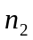= 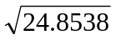
∴ = 4.98 ≈ 5
Ans. = 5

8. A line of the Balmer series of the hydrogen atom spectrum has the wavelength 397nm. It results from a transition from upper energy level. What is the principle quantum number of that upper level?

Solution: Since line is of the Balmer series so n₁= 2 and n₂ =? Here λ = 397nm = 397x10⁻⁷ cm.
[Since Rydberg constant is in cm⁻¹ unit so we are taking wavelength in cm unit]
We know that =
or, = where R is the Rydberg constant having value 109,676 cm⁻¹
Putting the values we get,
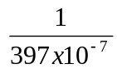 = 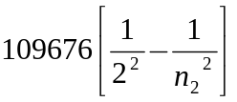
or, 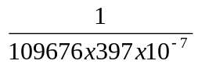 = 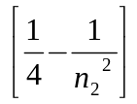
or, = -
or, = - 0.2296666
or, = 0.0203333
or, = 49.18
or, = 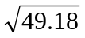
∴ = 7.01 ≈ 7
Ans. = 7

9. State which of the following sets of quantum numbers would be possible and which would be impossible for an electron in an atom.

a) n=0, l= 0, m= 0, s= +½ [Impossible]
b) n=1, l= 1, m= 0, s= +½ [Impossible]
c) n=1, l= 0, m= 0, s= -½ [Possible]
d) n=2, l= 1, m= -2, s= +½ [Impossible]
e) n=2, l= 1, m= -1, s= +½ [Possible]

10. State which of the following sets of quantum numbers is permissible for an electron in an atom. If a set is not permissible, explain why?

a) n=1, l= 1, m= 0, s= +½
b) n=3, l= 1, m= -2, s= -½
c) n=2, l= 1, m= 0, s= +½
d) n=2, l= 0, m= 0, s= 1
e) n=3, l= 2, m= 3, s= +½
f) n=3, l= 2, m= -2, s= 0

